**Assignment No : 15**

**Problem Statement : Create a serverless computing service**.

1. Log in to AWS & goto ‘Lambda’.

Click on ‘Create a function’.

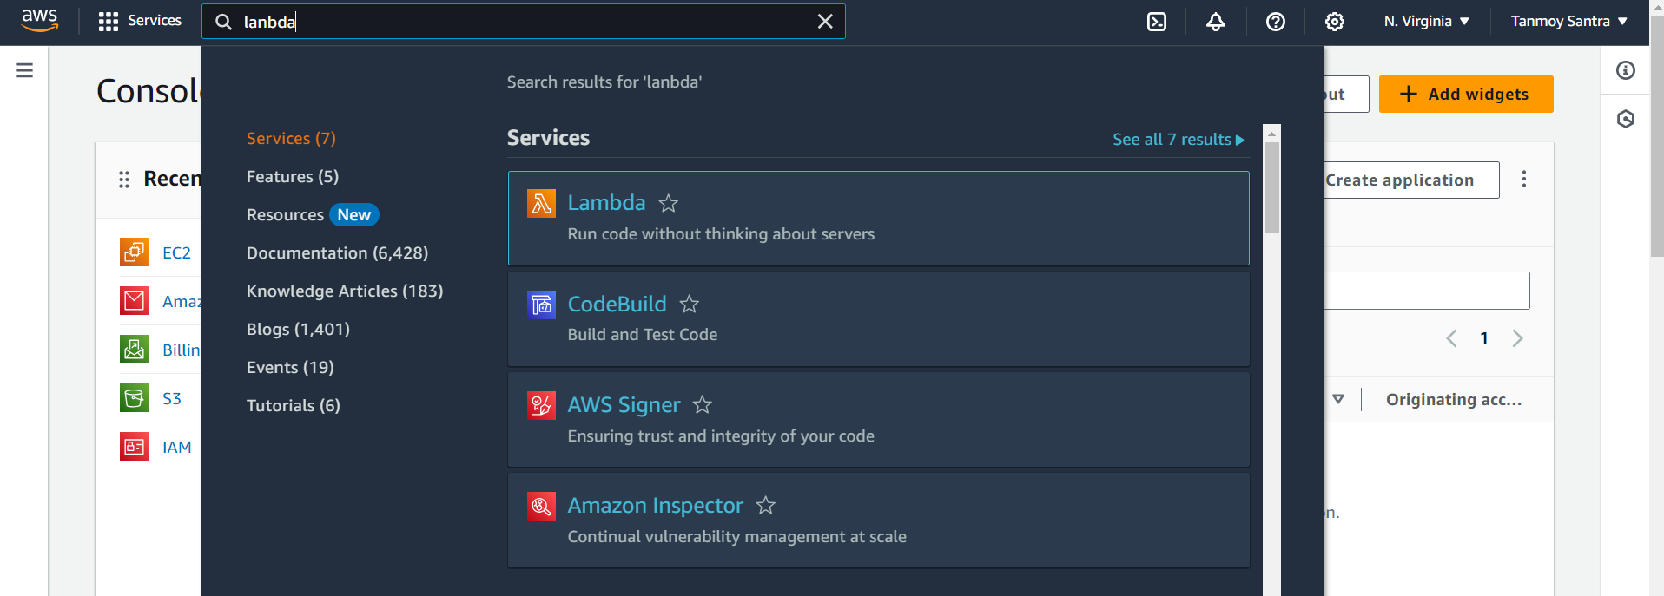

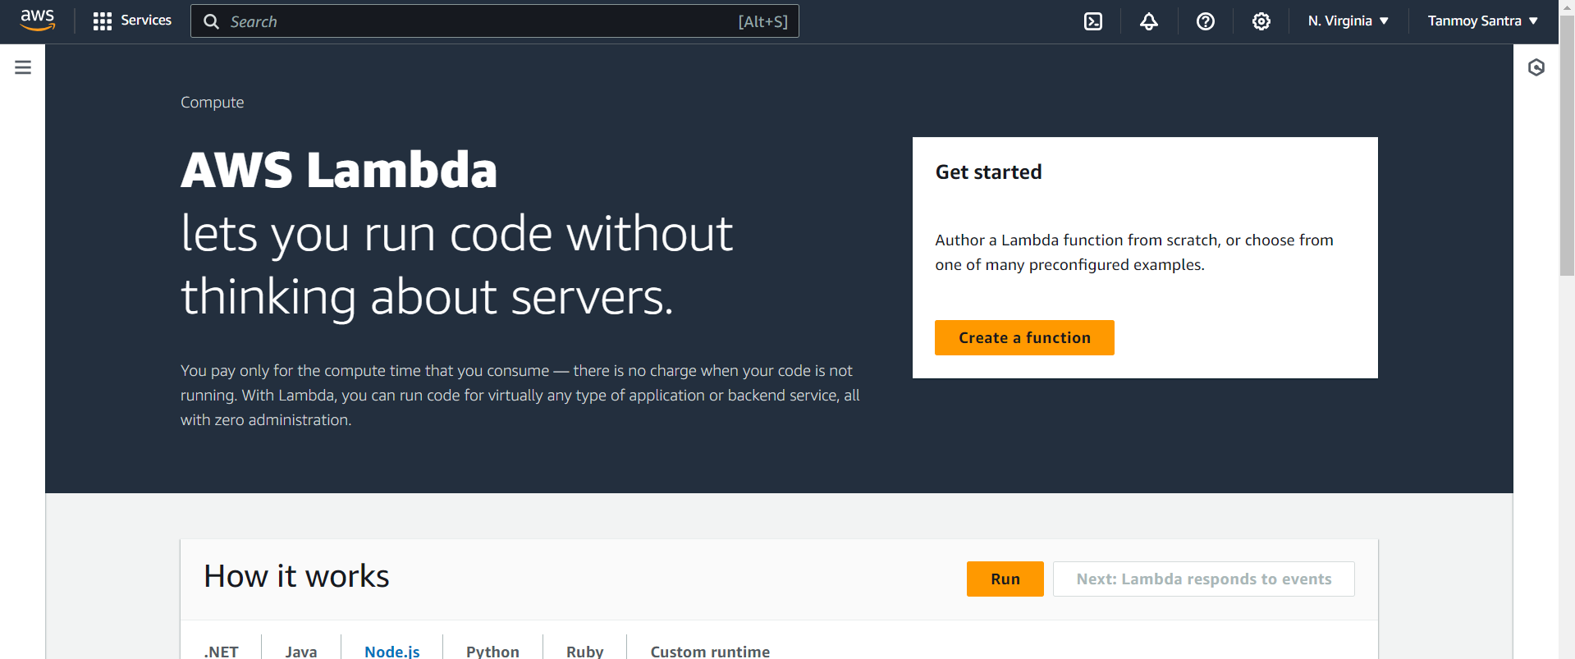

1. Give a function name. (Ex-func1),Select language in Runtime section. (Ex-Python 3.12),Click on ‘Create function’.

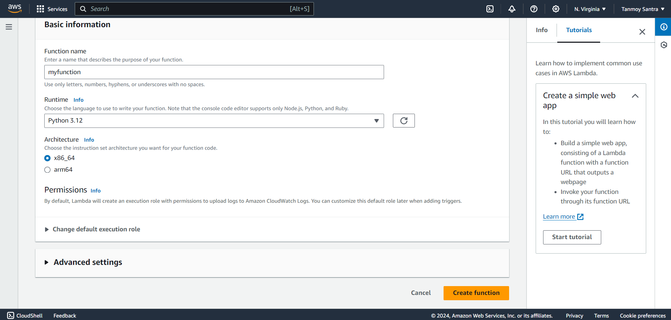

1. The function named "func1" has been successfully created

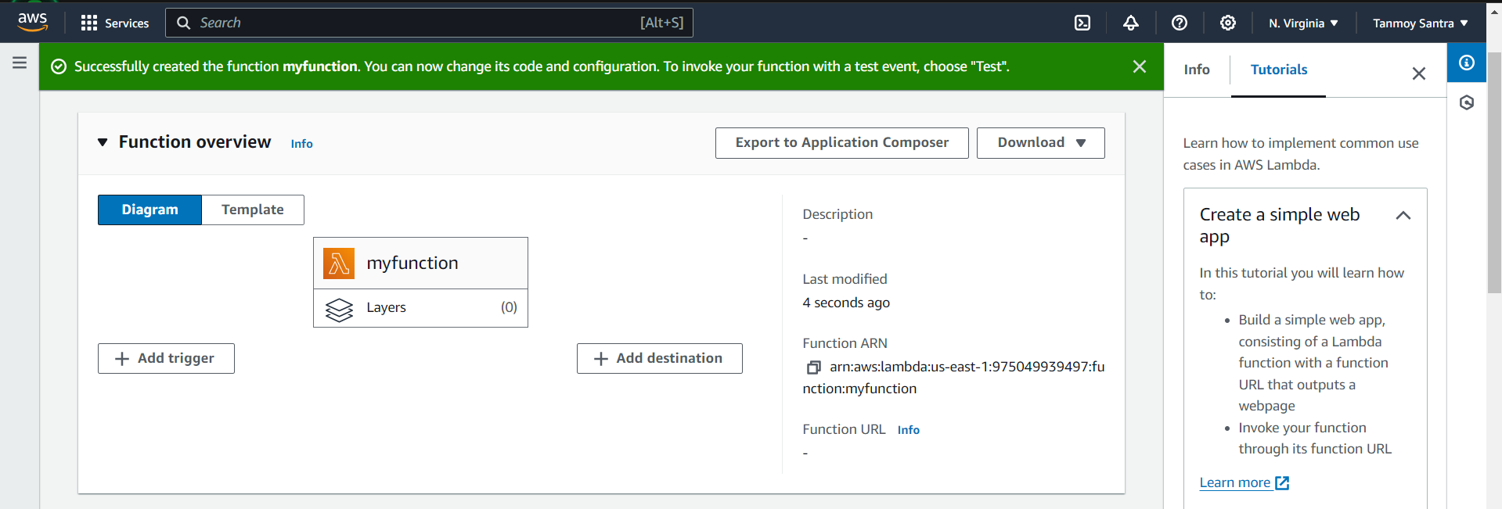

1. Scroll down to access the code section.

Make the necessary modifications to the code.

Click ‘Deploy’ to save the changes.

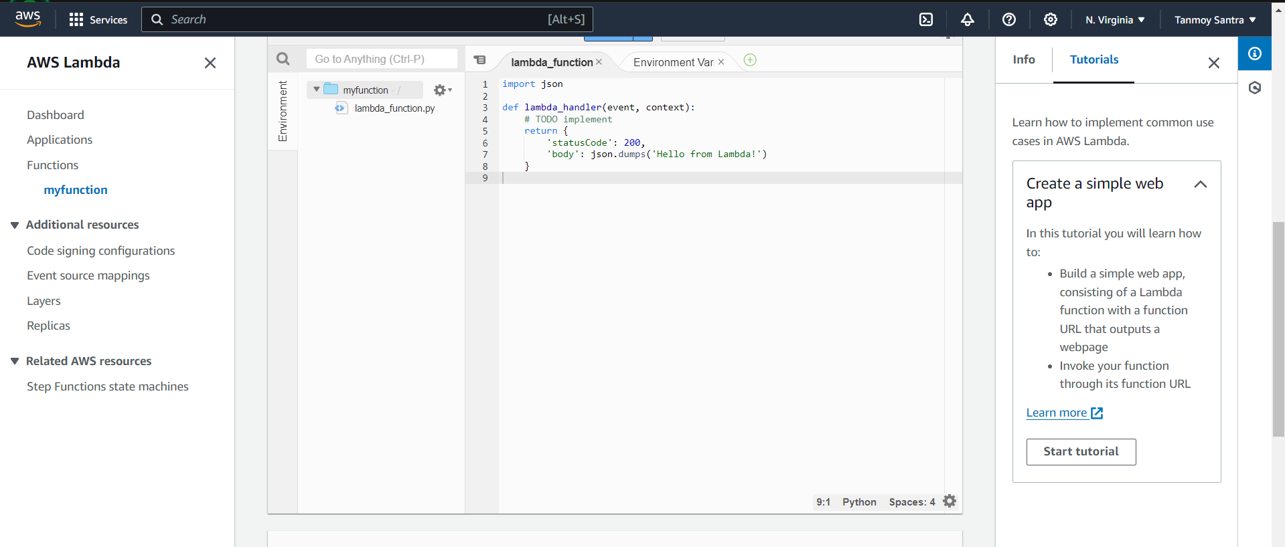

1. Click on ‘Test’ next to ‘Code’. Select ‘Create new event’. Give event name. (Ex-event1). Click ‘Test’ button to test the function.

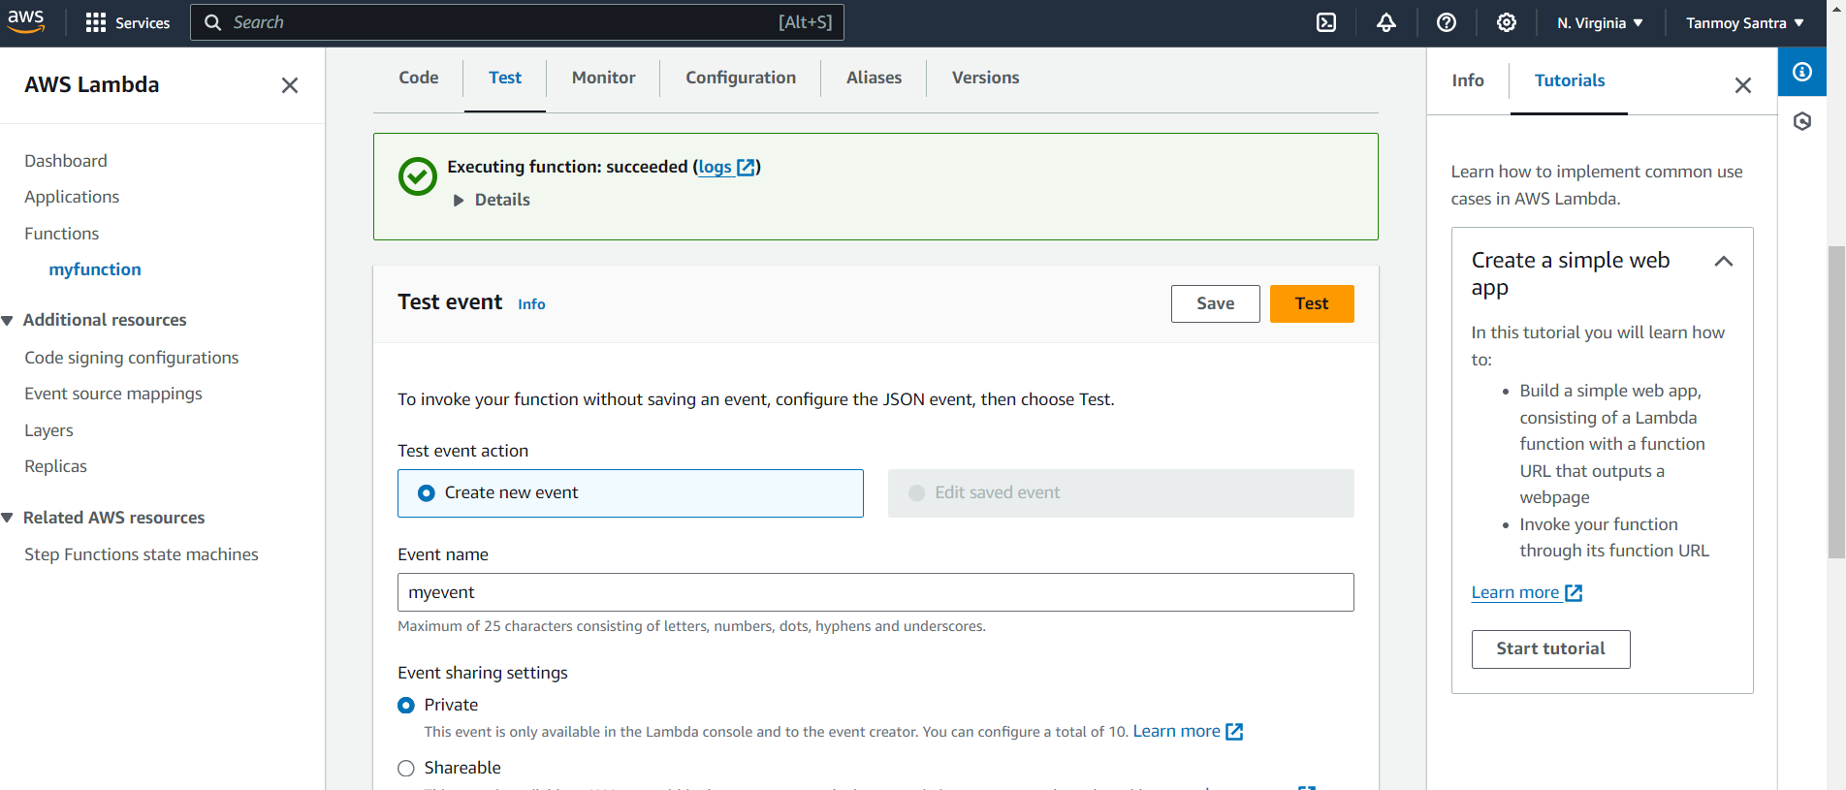

1. Click on ‘Configuration’.

Goto ‘Function URL’ from the left menu of configuration section.

Click on ‘Create function URL’.

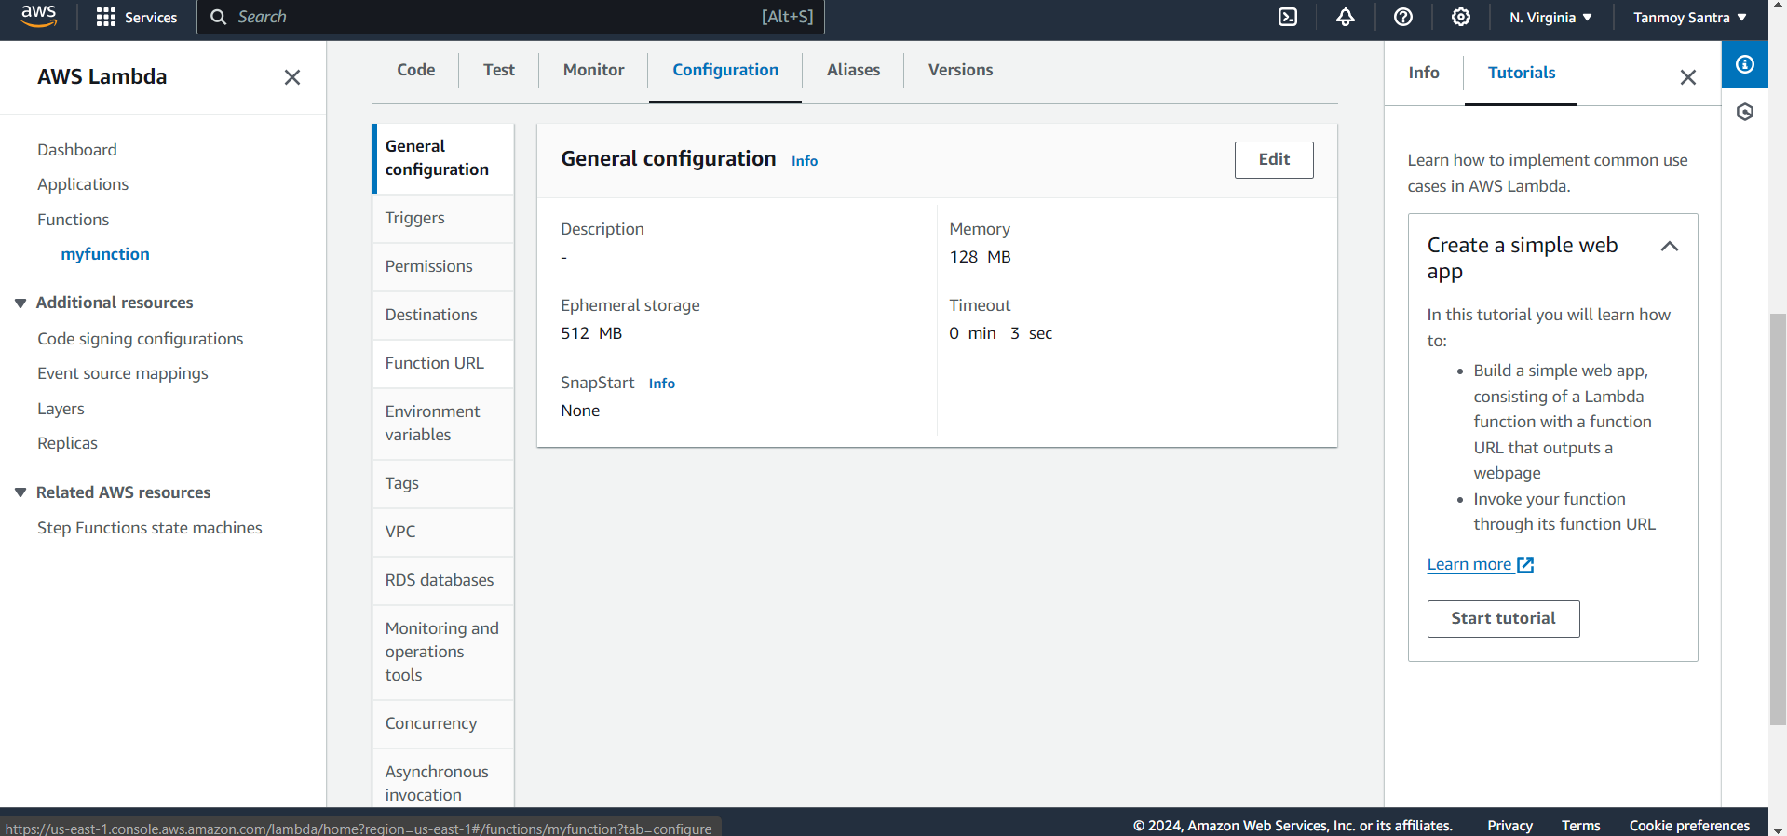

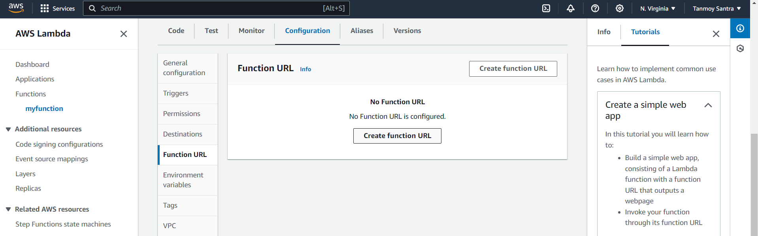

1. Select Auth type ‘NONE’  
   Click ‘Save’.

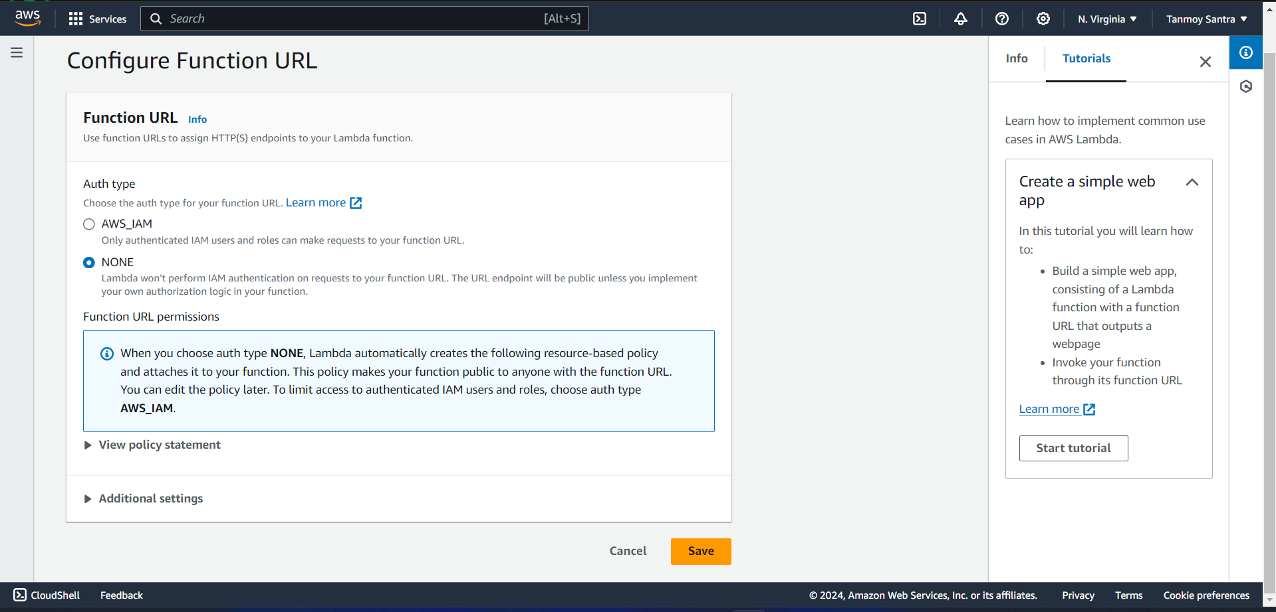

1. Function URL has been generated successfully.  
   Copy the Function URL from the right section.

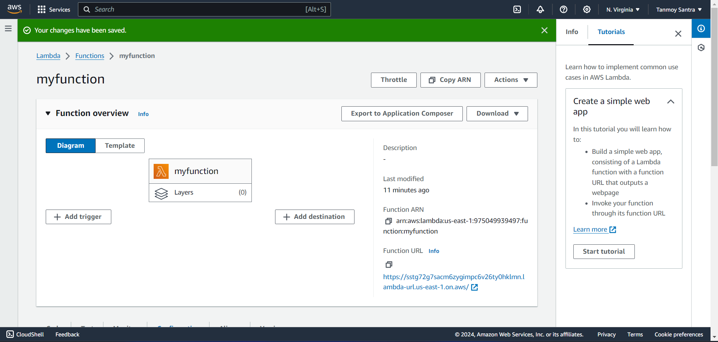

1. Paste the url in browser to get output of the code.

